

**Web Wallet**

Lab Manual



May 12, 2023

Nobel institute of technology

Junagadh

**-:Chapter 1:-**

**Introduction**

**&**

**Conclusion**

**Introduction :-**

The project was aimed at designing and developing a banking website that caters to the needs of users for managing their banking transactions online. In Semester 5, the team successfully completed the user-end of the website.

This report presents an overview of the work completed in Semester 5 and the progress made in the current semester towards completing the Admin Panel.

**Overview of Semester 5 :-**

In Semester 5, the team worked on designing and developing the user-end of the banking website. The team started by identifying the requirements of the website and creating a blueprint of the website's architecture. The team then worked on developing the website's front-end, which included designing the website's layout, interface, and user experience. The team also developed the website's back-end, which involved implementing functionality for user registration, login, account management, transaction history, and fund transfers.

Throughout Semester 5, the team faced several challenges, such as technical issues, design constraints, and time constraints. However, the team was able to overcome these challenges through effective communication and collaboration. By the end of Semester 5, the team had successfully completed the user-end of the banking website and tested it for functionality and usability.

**Progress on Admin Panel :-**

In the current semester, the team is working on completing the Admin Panel of the banking website. The Admin Panel will provide the bank's administrators with access to various features and functionalities such as account management, transaction monitoring, customer support, and data analysis.

The team started by creating a blueprint of the Admin Panel's architecture and design. The team is now working on developing the Admin Panel's front-end and back-end, which includes implementing features such as user management, transaction tracking, customer support, and data analytics.

The team has faced several challenges in developing the Admin Panel, such as integrating the Admin Panel with the existing user-end, ensuring data security, and maintaining user privacy. However, the team has been able to overcome these challenges by using industry-standard technologies and practices, as well as effective communication and collaboration.

**Analysis and Reflection :-**

Overall, the project has been a challenging yet rewarding experience for the team. The team has gained valuable knowledge and skills in web development, project management, and teamwork. The completion of the user-end in Semester 5 has provided a strong foundation for the team to build upon in completing the Admin Panel in the current semester.

Looking back at Semester 5, the team faced several challenges, such as technical issues, design constraints, and time constraints. However, the team was able to overcome these challenges through effective communication and collaboration, as well as using industry-standard technologies and practices.

Moving forward, the team is committed to completing the Admin Panel and delivering a high-quality banking website that meets the needs and expectations of its users.

**Conclusion :-**

In conclusion, the project has been progressing well, and the team is confident in completing the Admin Panel as per the project timeline. The team has successfully completed the user-end in Semester 5 and is now working on completing the Admin Panel in the current semester. The project has been a valuable learning experience for the team and has provided valuable skills and knowledge in web development, project management, and teamwork.

**-:Chapter 2:-**

**Database & Web Design**

**Introduction :-**

In this chapter, we will discuss the database and web design aspects of our banking website project. We have included images below to provide visual context for our readers.

**Database Design :-**

Our database design includes tables for storing user information, account details, and transaction history. We used MySQL as our database management system. The image below shows the Structure of our database:

**Database Structure:-**

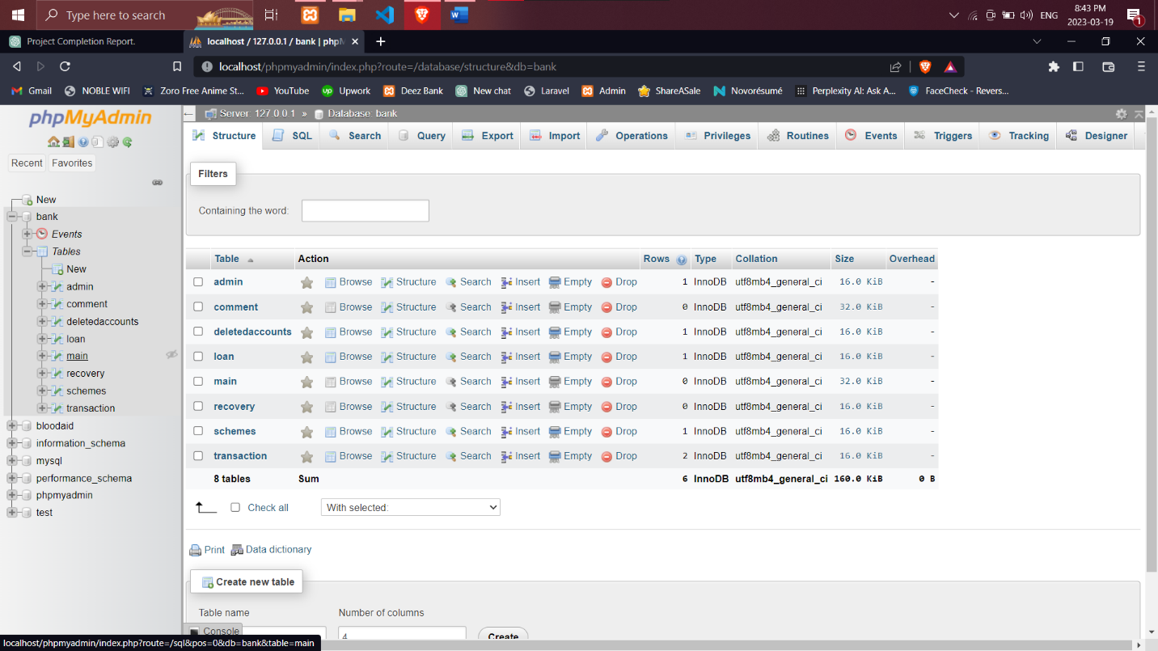

**Admin Table:-**

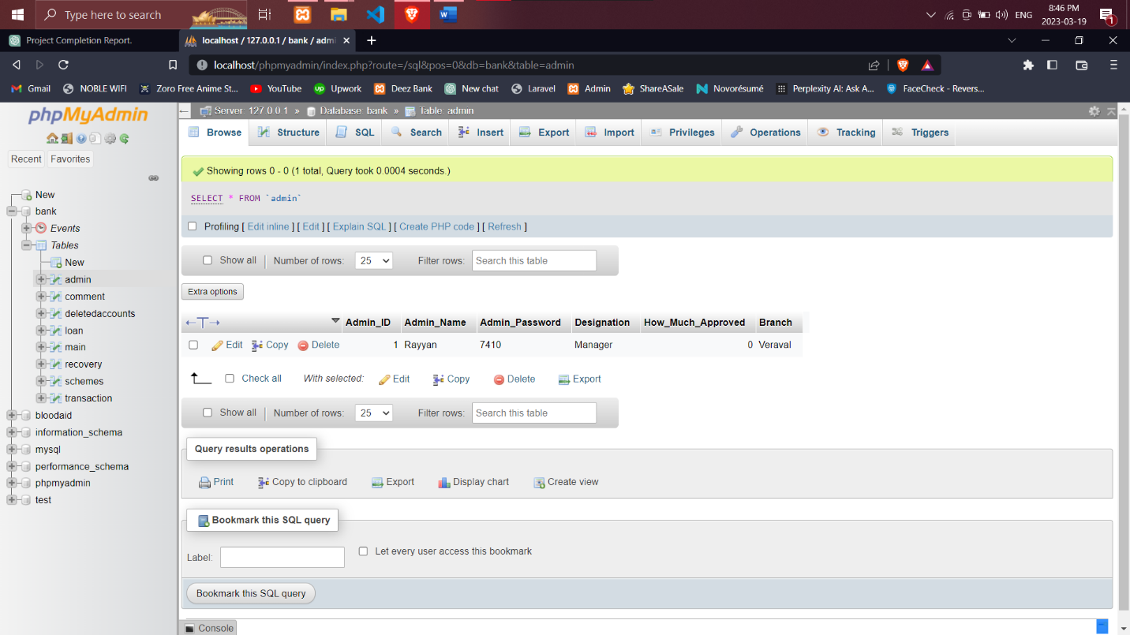

**Comment Table:-**

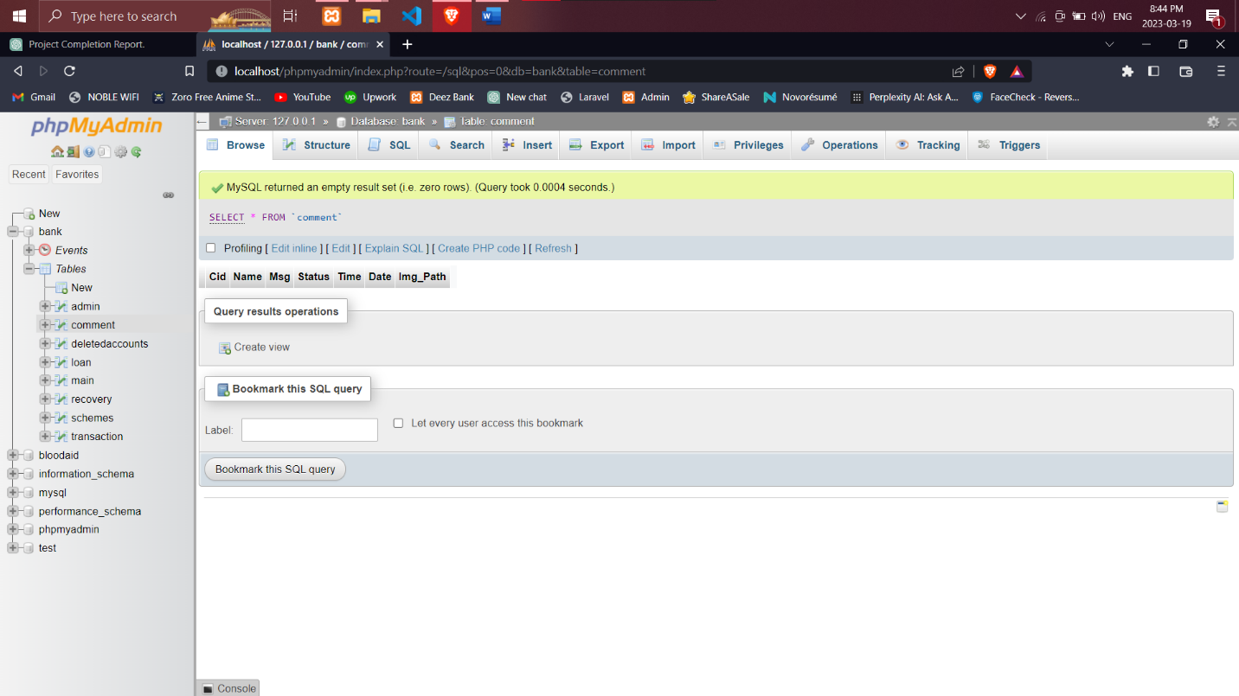

**DeletedAccounts Table:-**

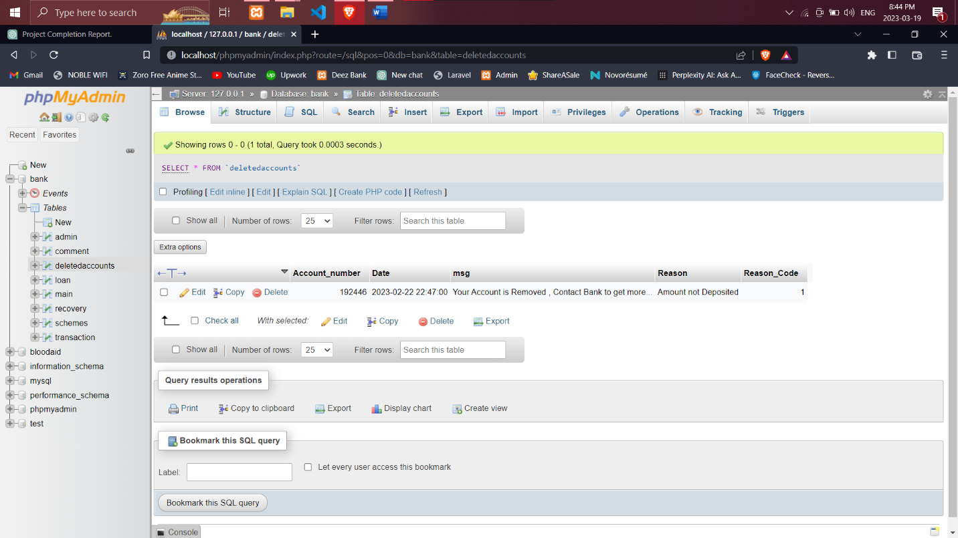

**Loan Packages(Schemes) Table:-**

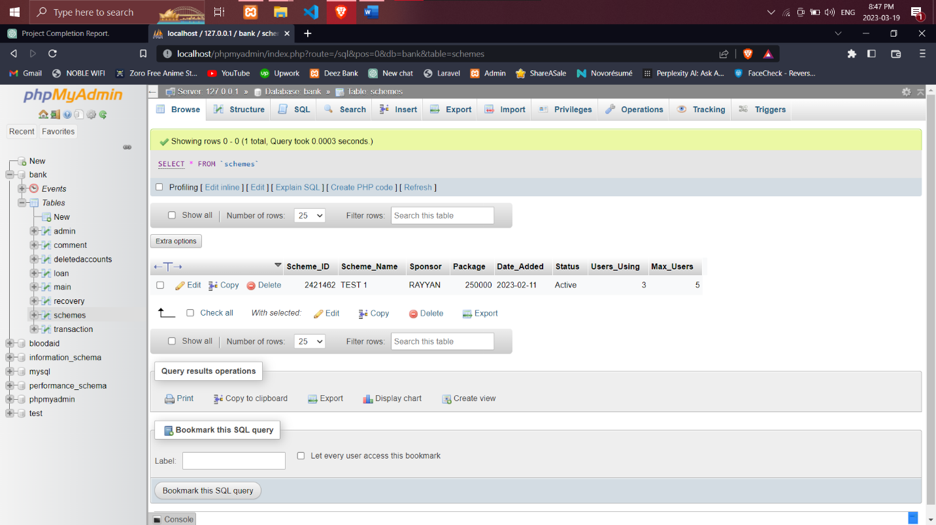

**AccountHolders(Main) Table:-**

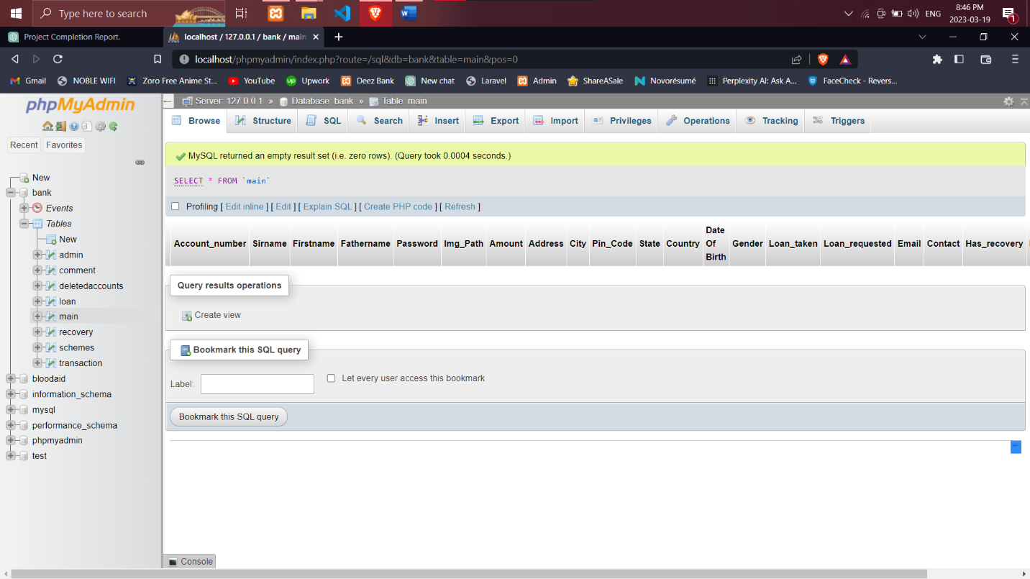

**Recovery Table:-**

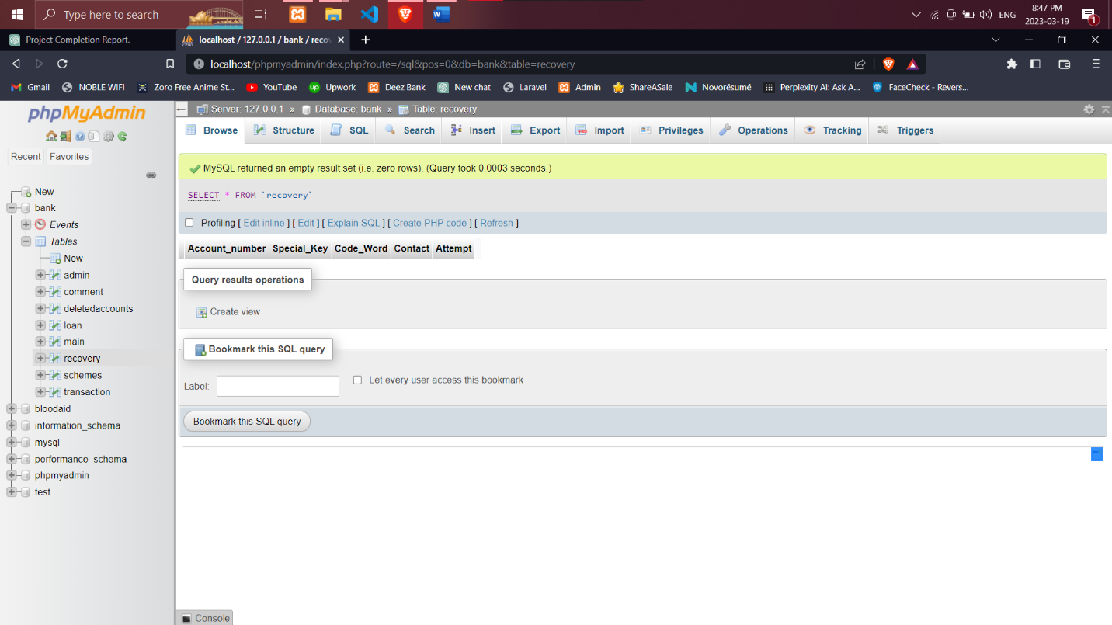

**Transactions Table:-**

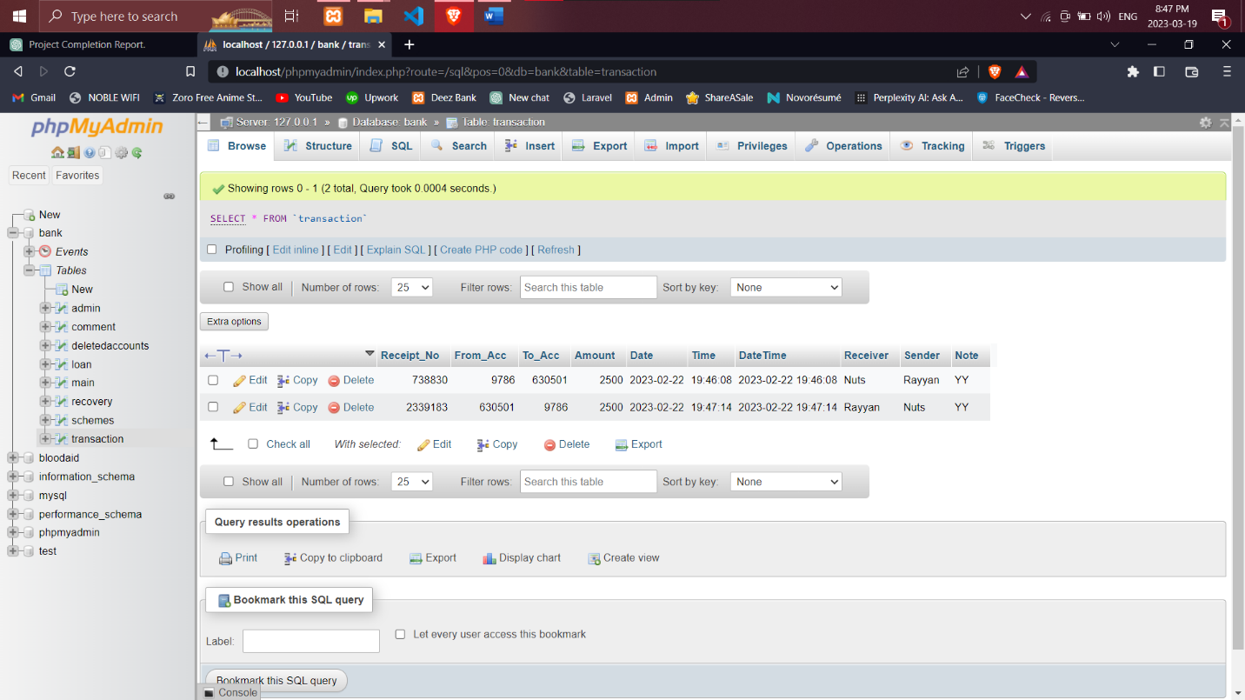

**Event:-**

One of the advanced features we incorporated into our database design is the use of events. An event is a scheduled task that automatically performs a specific action in the database at a predefined time. We used events to automate certain tasks such as if a User Creates an Account and Does’nt Deposit Minimum Amount into his Account his Account Will be Soft Deleted.

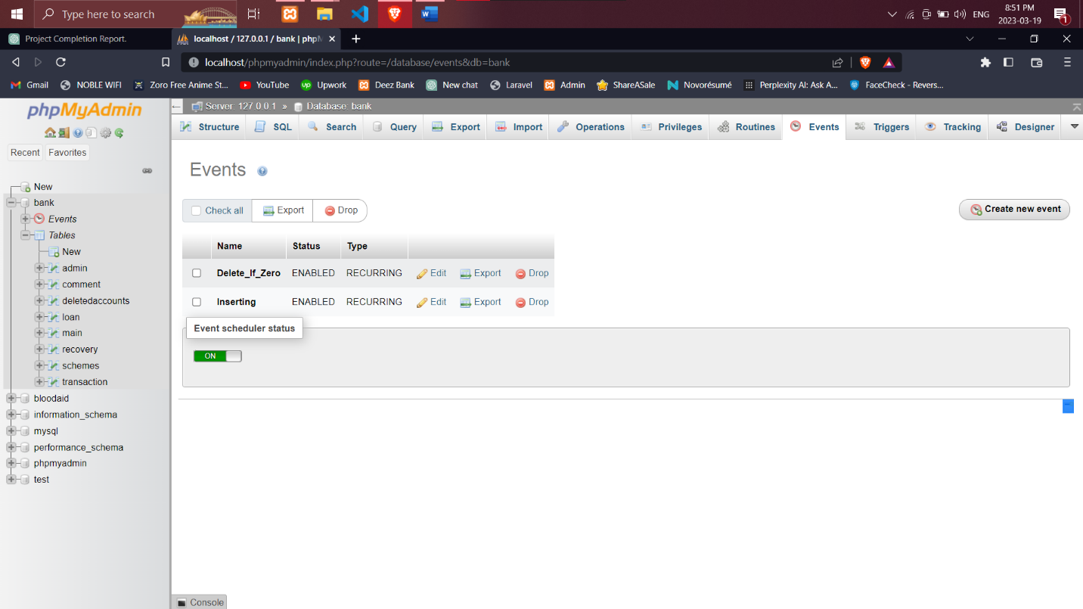**Events(Delete_if_Zero && inserting):-**

**Web Design :-**

We designed our banking website with a clean and user-friendly interface. The website includes features such as user registration, login, account management, transaction history, fund transfers, Loan Application Form & Dashboard. The images below provide a glimpse of our web design:

**Welcome Page :-**

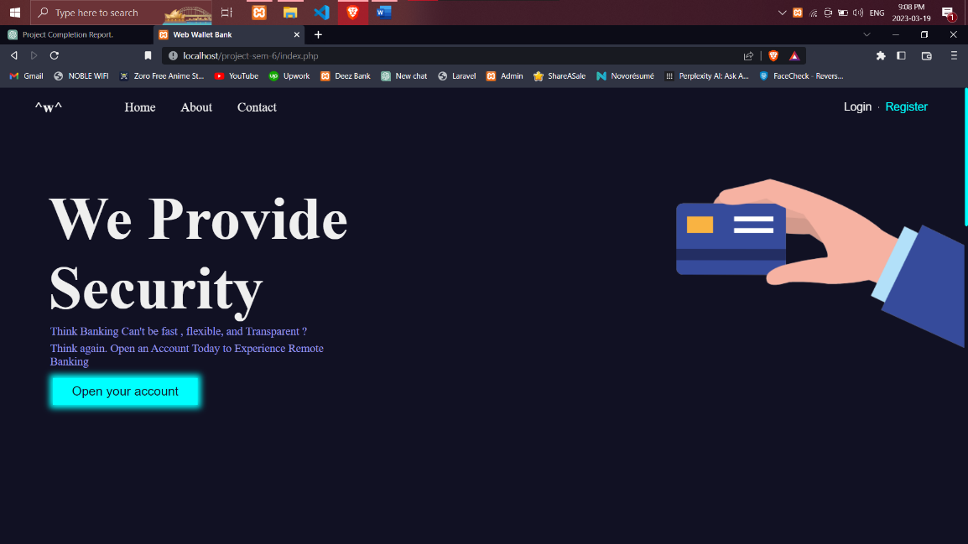

**Login Form :-**

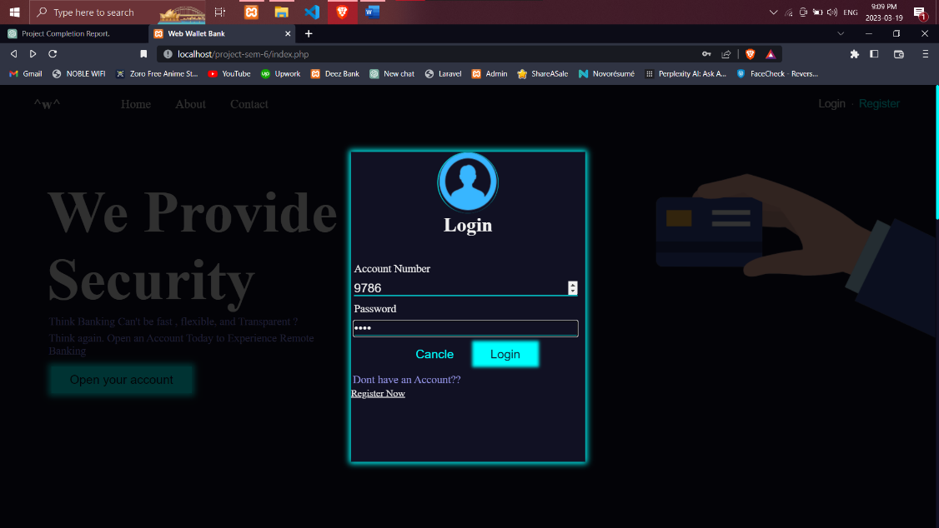

**Signup Pages :-**

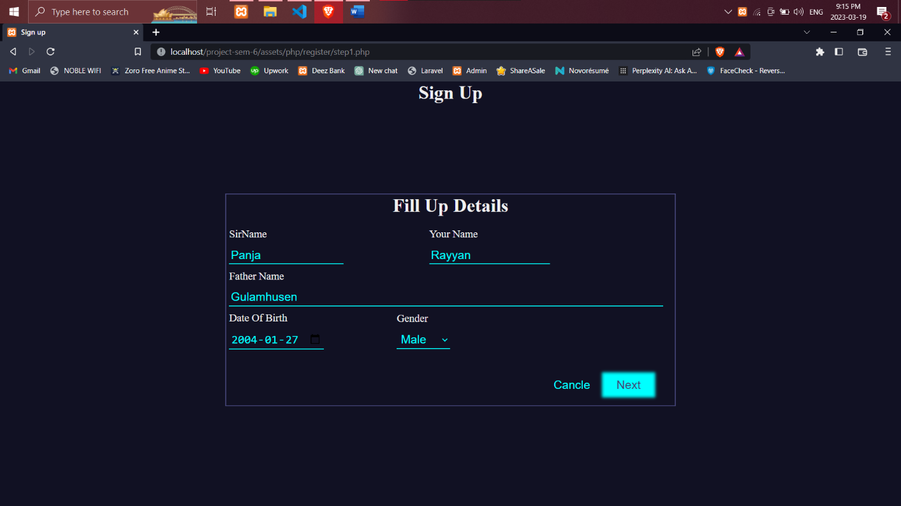

**Home Pages :-**

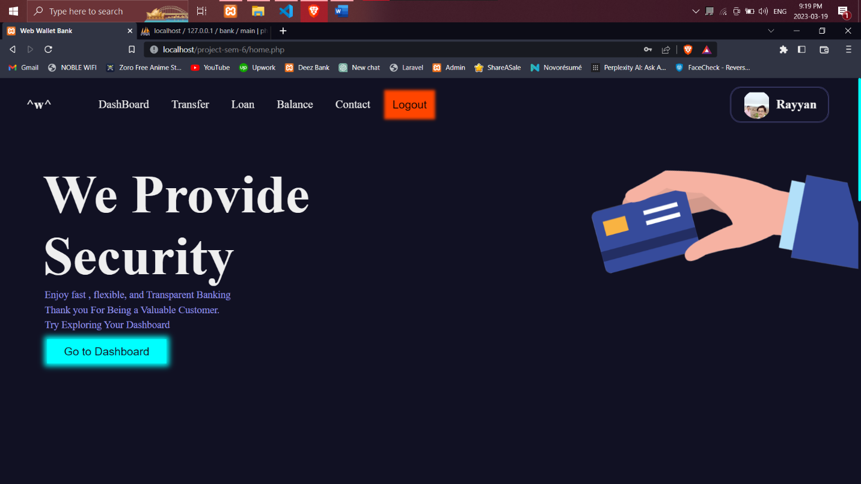

**Fund Transfer Pages :-**

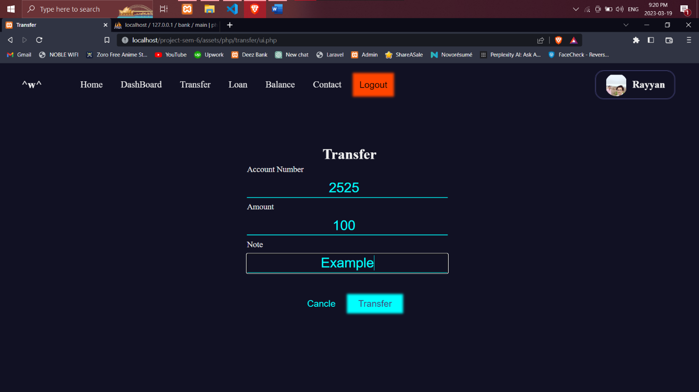

**Loan appli. Pages :-**

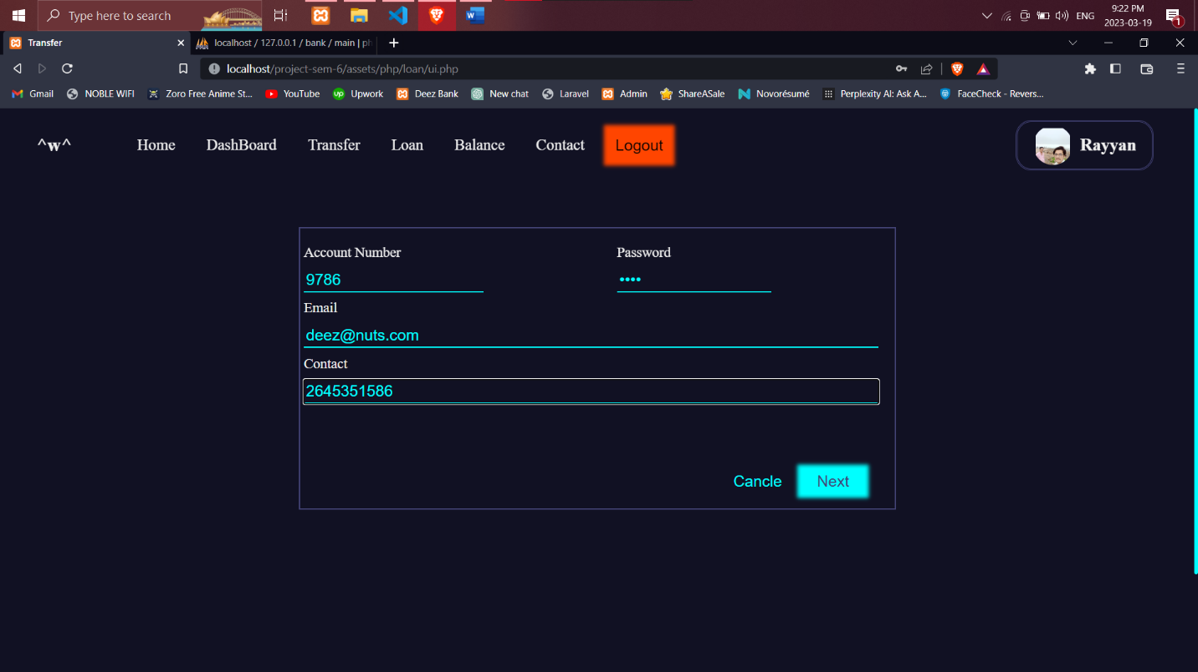

**DashBoard Pages :-**

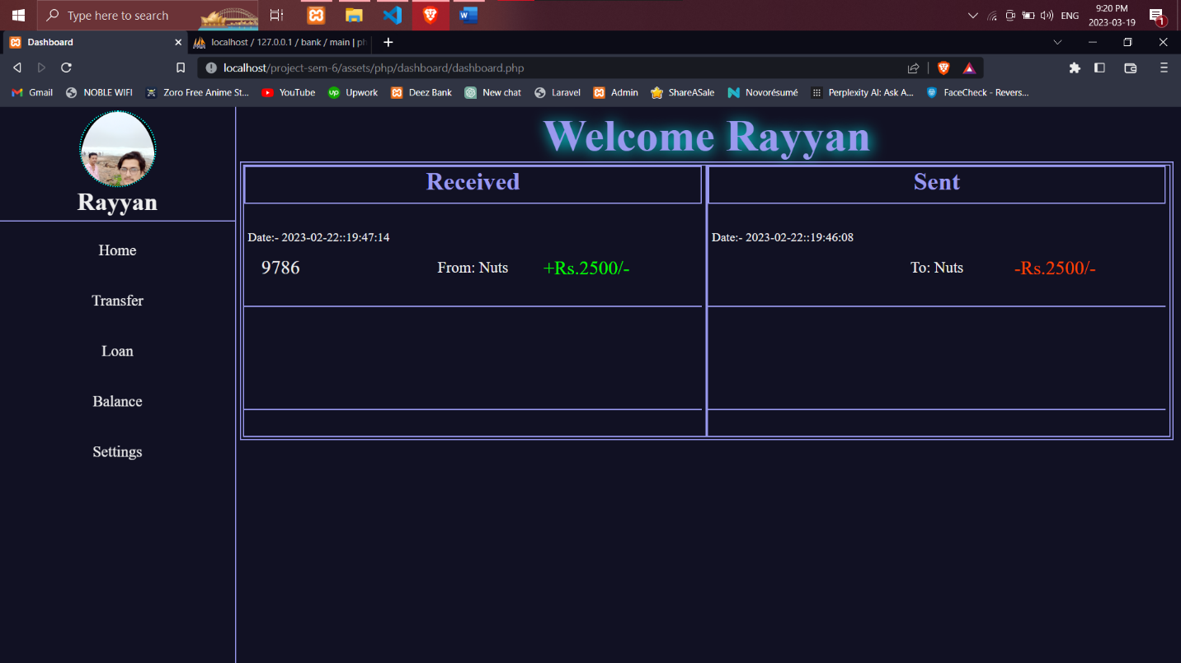

**Balance Pages :-**

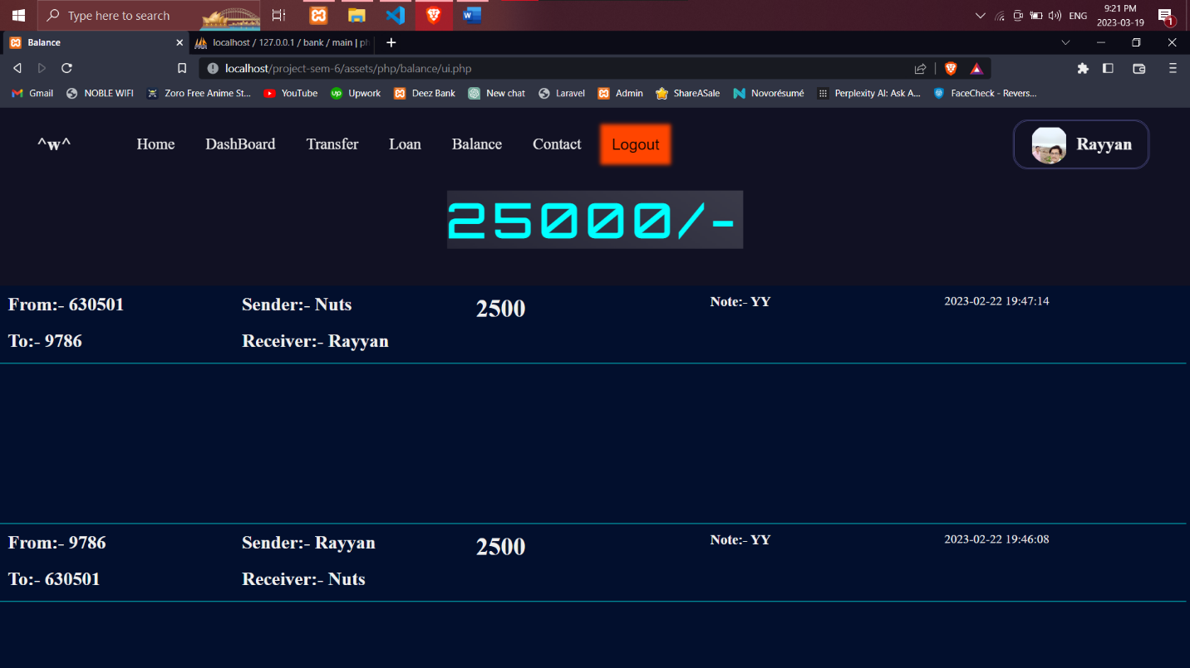

**-:Chapter 3:-**

**Introduction**